Week In Review: January 17 - 23, 2002
Alex Shvartsman

Grand Prix-Lisbon
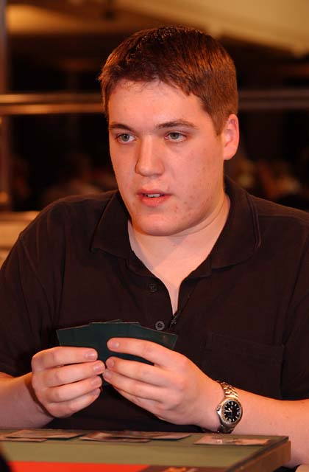
How do you beat a man who mulligans to 0 and STILL wins the GP?
670 players met in Lisbon, Portugal to play in the last Grand Prix of the Extended season, and 100th Grand Prix overall. The organizers celebrated the occasion by offering a bottle of champagne to every player who played a match at table 100 over the course of 8 rounds of day 1. The player who finished in 100th place overall - Carios Sanchez Brito - received a prize of 100 booster packs.
The metagame for this tournament was heavily geared toward Miracle Grow and Sligh, with fair amount of Junk in the mix. Among the players with 3 byes, Oath was one of the most popular strategies. Oath variants were geared to defeat Miracle Grow, but often ran into trouble when facing Sligh decks.
Pro players did not disappoint, creating a high-profile Top 8. From The Netherlands, Jelger Wiegersma navigated a blue-green Oath deck to a Top 8 finish. His countryman and the current world champion Tom van de Logt placed 7th with a Sligh deck very similar to Bob Maher's, except that he played Price of Progress over Chimeric Idol in the main deck. I placed sixth for the second Grand Prix in a row, to earn my 15th GP Top 8 finish overall, playing Super Grow. Italian Stefano Fiore, Miracle Grow, and Portuguese Marcio Carvalho, Sligh were the only unknown factors in this Top 8. Olivier Ruel, also with Super Grow, continued to challenge my Grand Prix record by placing in another Top 8 as well.
In the finals, it was the teammates Kai Budde and Patrick Mello, playing a mirror match with their Oath of Druids decks. The marathon finals lasted over three hours, despite the best efforts from the two players to finish it sooner. After an exhausting game 1, which Mello won, the two players sideboarded face up, agreeing to take out Oath of Druids and Counterspells, to make the game go faster. The plan did not work, as the second game lasted for almost an hour and a half, Budde eventually taking the win. The stall was partly due to the two Morphlings facing off for a very long time. For game three, not only did the two players board out their Morphlings and Gaea's Blessings, but they also agreed to each mulligan down to zero cards, leaving the game to luck but hoping it will end quickly! Even so, the game lasted a while, but Kai drew better and was eventually able to claim victory.
Budde now holds the unprecedented record with 5 Pro Tour wins AND 5 Grand Prix wins. A fitting ending to 100th Grand Prix in history of the game.

Coming Up: Torment Prerelease

The new set is about to be unveiled this weekend. This has been probably the most previewed set in history, with so many cards uncovered on The Sideboard, on MagicTheGathering.com and in InQuest. There are even more cards revealed in the Torment FAQ, which you should definitely read before heading out to the Prerelease.

New Pro Tour Locations

The first two Pro Tour locations for the 2002-2003 season have been announced. For the first time ever, New York will not host a Pro Tour this year. Instead, the team Pro Tour has been moved to Boston. The circuit will also not return to New Orleans in 2002. Instead, the second Pro Tour of the season will be held in Houston. That means every single Pro Tour held in 2002 will have taken place in a brand new location. Good news for residents of those cities, bad news for New Yorkers like me.

Quote of the Week
In the 3 hour long finals of GP Lisbon:
Budde: "I think he (Mello) is going to deck me."
Mello: "NOOOOOO!"

Magic Trivia
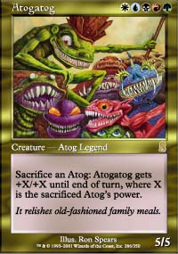
Last week's question:
What rare card was designed for Unglued II and eventually printed in Odyssey, artwork and all?
It was Atogatog. A number of other Unglued II cards sneaked their way into the real Magic sets. For example, the split cards such as Fire/Ice were an Unglued II mechanic.
New question:
Who are the only players to have defeated Kai Budde in Grand Prix Top 8's?
Please do not email answers to me. The correct answer will be posted in the next column.

Play of the Week
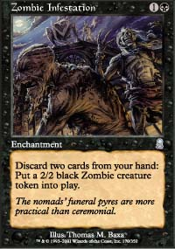
It's Zombie Infestation week here at the Play/Bad Play section.
Courtesy of Tim Willoughby
"In Standard testing over the holidays this rather entertaining exchange took place...
I was playing u-b Upheaval/Infestation against Chanting Angel. After a relatively tight first couple of games, I found myself sitting quite happily with 8 lands in play and all the combo pieces in my hand. Deciding that I wanted to get my combo out before Tom, my opponent, could draw his, I played Upheaval, floating ub to cast the Infestation I was holding. Imagine my horror when he responded with an Orim's Chant! This left me in the worrying position of not being able to cast my Infestation and possibly taking mana burn as well to add insult to injury. Without enough land out to be able to counter his Chant and play my Infestation, I was all ready to let my Upheaval backfire rather dramatically. However, playing blue I felt that there had to be some way that I could get myself out of this rather awkward situation. Imagine Tom's disgust when I cast Memory Lapse in response to his Chant on my own Upheaval, leaving me to happily go off next turn instead."

Bad Play of the Week
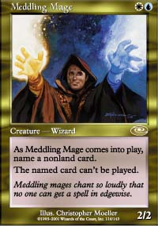
Pikula's good, but not omnipotent
Courtesy of James Dykes:
"It was game 3 of a local Standard tournament and it's myself vs. Ryan Cheng. I'm playing u-r-w Aggro, he's playing Zombie-Go. I have only a Meddling Mage on the table, locking down Zombie Infestation. He's swinging and the clock is ticking. Ryan gets to 9 lands with some help from Fact or Fiction. He Upheavals and says go. I lay down a land and pitch down to a 4 land, 2 Prophetic Bolt, Meddling Mage hand. He draws, lays a second land, and drops a Zombie Infestation. I compliment him on his top-decking skills. He then says he's had the Infestation in his hand the entire time. I ask him why he didn't play it after the Upheaval then. He comments on the Meddling Mage which everyone around reminds him doesn't affect the board once it goes back to my hand. He cringes as I draw and push a Lightning Angel through 2 turns later to win."
Got an interesting news story, comment, quote, play of the week, or Magic trivia to report? Please e-mail me at ashv80@hotmail.com.

